**JINO P. DOCENA**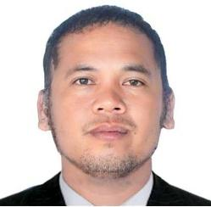

Aspiring General Virtual Assistant

Web Developer

Graphic & Media Editor

Location: Taft, Eastern Samar, 6816

Phone Number: 906-597-1842

Email Address: jinodocena11@gmail.com

## Overview: I am a skilled aspiring virtual assistant/web developer/graphic & media editor who's looking forward to supporting business owners with their virtual needs so they could focus more on their business needs and personal lives. My goal is to lessen client's workloads and take part in operating the business in any aspects they need help with and to contribute to the company's success story.



# Educational Background

## Master of Arts in Teaching Vocational Education – Major in Information and Communication Technology

## Eastern Samar State University | 2024 – Present (30 units earned)

## Bachelor of Science in Computer Science

## Eastern Samar State University | 2002 – 2010

## 

## Work Experience

Administrative Aide

Philippine National Police 2014 – 2023

## Administrative Aide (Municipal Budget Office)

Local Government Unit - Taft 2010 – 2013

## Clerical Aide (Registrar's Office)

## Technical Education Skills and Development Authority

2007 – 2009

## Certifications & Trainings (via Coursera, 2024)

* Google Cybersecurity
* Google Advanced Data Analytics
* Create a Mockup in Figma
* How to Design Facebook Using Canva
* Video Editing Basics

## Technical & Digital Skills

* Office Tools: Microsoft Office, Google Workspace
* Design Tools: Canva, Figma
* Video Editing: CapCut, Filmora
* Web Development: Basic HTML/CSS, ReactJS
* Programming: Python (Beginner level)
* Data Skills: Excel (Spreadsheets), Data Entry